Dear Parents,
In 2017 we would like to offer our French students from Year 3-6 the opportunity once again to take part in the Alliance Française Poem Recitation Competition.
Poetry reciting is taught extensively in schools in France and other francophone countries and is a big part of growing up in the French school system. Most French people still remember their favorite poems learned as a child!
We will be spending a lesson to introduce the poem for the year group and talk about some strategies to learn the verses by heart in our French class.
Students who wish to enter the competition are asked to practice the poems over the April holidays at home. Please find the selected poems on the next page, links to the audio recording are also available.
If your child wishes to participate in this event, please fill in the entry form below and return it to Madame Carniello by the 27 April (Week 1, Term 2). All participants are required to submit a video recording of the student reciting the poem. This recording can be done at home (the students full body needs to be visible) or can be done at school.
An Alliance Française jury will select the finalists who will be invited to recite their poem at the Grand Final on Saturday, 17 June at the Alliance Française in Nedlands.
Please don’t hesitate to contact me if you have any questions about the Competition. More competition details can also be found on the Alliance Française Perth website.
Bien cordialement,
Madame Carniello
-----------------------------------------------------------------------------------------------------------------------
ENTRY FORM NEEDS TO BE RETURNED BY 27 APRIL 2017 to Madame Carniello.
I, ___________________________________would like to enter the Alliance Française Poem Reciting Competition 2017.
I understand that I will need to learn the poem by heart and submit a video recording of me reciting the poem by the 27 April to Madame Carniello.

Student Signature | Class | O I will submit my own video recording  O I would like to be filmed at school (Monday 1/5 and Tuesday 2/5 at Lunchtime)
Parent Signature | Date
POEM SELECTION 2017
Year 3 & Year 4 | Year 5 & Year 6
J'aime ma maison  J'aime ma maison chaude  L'hiver quand le vent rôde.  Le printemps y pénètre  Par toutes les fenêtres  Sous le soleil qui sèche,  L’été, comme elle est fraîche !  Elle est douce en automne  Dans le parfum des pommes  Je t'aime bien, maison  Souriant aux saisons.  Louis Guillaume | Reconnais-toi  Cette adorable personne c'est toi  Sous le grand chapeau canotier  Oeil  Nez  La bouche  Voici l'ovale de ta figure  Ton cou exquis  Voici enfin l'imparfaite image de ton buste adoré vu comme à travers un nuage  Un peu plus bas c'est ton coeur qui bat  Guillaume Apollinaire  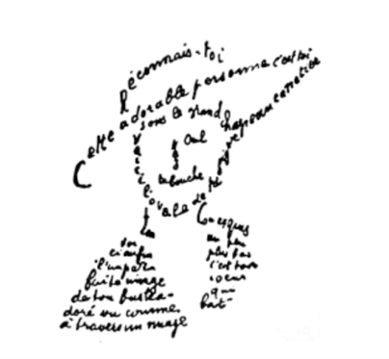
The spoken text can be found on the Alliance Française website
Audio Recording
http://www.afperth.com.au/french-courses-learn-french/af-french-schools-exams/af-poem-recitation-competition/

